Décor Mr & Mrs
Remote Instruction menu
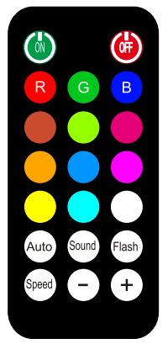
specifications :
•Auto shift，Fade，Sound active and static color mode.
•Infrared remote control(Max.10M)
•Fire retardant housing material.
• LEDS : 801pcs（R*267，G*267，B*267）
•Power supply：100-240V AC 50/60HZ
•Power Consumption：72W
•Dimensions：1150*580*115mm*6pcs
•Weight：22KG
Controls and functions:
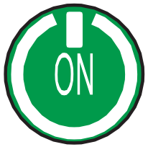 ：Set the LEDS into power on.
 : Set the LEDS into power off.
 : Set the LEDS color is red.  : Set the LEDS color is green.
 : Set the LEDS color is blue.  : Set the LEDS color is amber.
 : Set the LEDS color is yellow-green.  : Set the LEDS color is rose-red.
 : Set the LEDS color is orange.  : Set the LEDS color is sky-blue.
 : Set the LEDS color is magenta.  : Set the LEDS color is yellow.
 : Set the LEDS color is cyan.  : Set the LEDS color is white.
 : Set the LEDS into auto mode.
Then use“+”or “-” buttons to change auto program
program1 3 color jump change
program2 12 color jump change
program3 full color fade change
program4 12 color snap change
program5 12 color pulse change
program6 program1-5 cycle
Press”Speed”key then can be adjust the speed.
Press “+”/“-”to adjust the speed(Total 10 ranks)
1 : is lowest
10: is fastest

 ： Set the LEDS into sound mode.
Then use“+”or “-” buttons to change sound program
program1 3 color jump change
program2 12 color jump change
program3 12 color snap change
program4 12 color pulse change
program5 program1-5 cycle
 ： Set the LEDS to flash on and off.
then use “+”or “-” buttons to change flash speed
1 :is lowest
10: is fastest
 : Set auto run speed.

 : It is for adjust program of auto.
It is for adjust program speed of auto.
It is for adjust program of sound.
It is for adjust flash speed of static color mode (flash on ).
It is for adjust brightness of static color mode(flash off) .
Brightness :10 ranks
1:Darkest
10:Brightest

